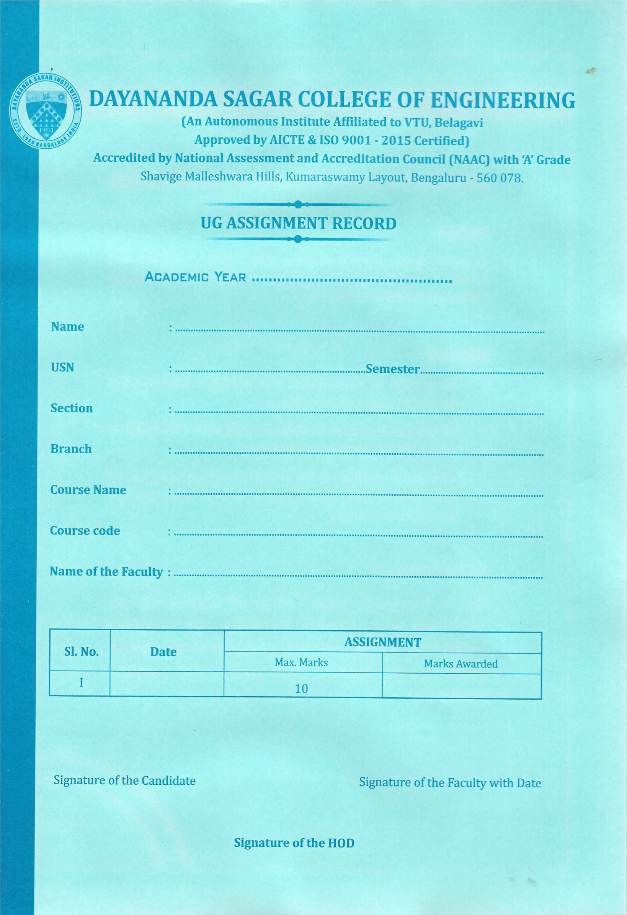

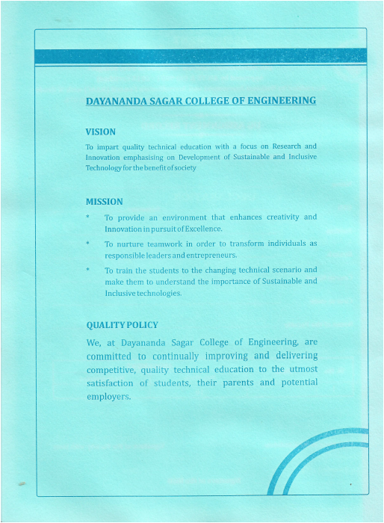

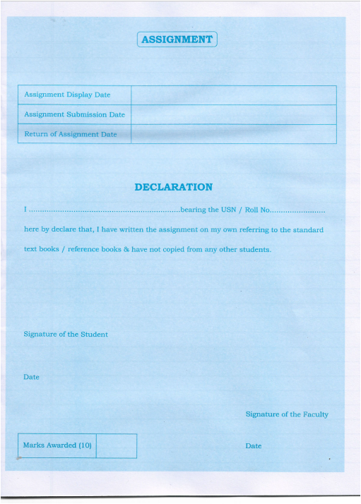

**CONTENTS**

**Pg.No:**

* Overview 4
* Topics covered 5
* Flowchart/Block diagram 6
* C++ Program Code 7
* Output 13
* Conclusion 14
* References 14

**IMPLEMENTATION OF VENDING MACHINE USING MEALY FINITE STATE MACHINE IN C++ LANGUAGE**

**OVERVIEW**

A vending machine is a machine that dispenses items such as snacks, beverages, and other goods after a customer inserts currency or a credit card. The vending machine uses a Mealy finite state machine (FSM) to control its operations.

The FSM for a vending machine using Mealy consists of several states including idle, coin accepted, item selected, item dispensed, and out of stock.

The idle state is the initial state of the vending machine, where it is waiting for a customer to insert coins or a credit card. When a coin is inserted, the machine transitions to the coin accepted state and waits for the customer to make a selection.

Once an item is selected, the machine transitions to the item selected state and waits for the customer to insert enough coins to pay for the item. If the customer has inserted enough coins, the machine transitions to the item dispensed state and dispenses the selected item.

If the selected item is out of stock, the machine transitions to the out-of-stock state and displays a message indicating that the item is not available.

Overall, the FSM for a vending machine using Mealy helps to control the operations of the machine and ensure that it functions correctly and efficiently for customers.

**TOPICS COVERED**

* Classes
* Structures
* Virtual function
* Constructor
* Pointer
* Function overloading/ function overriding
* Exception handling
* Inheritance

**FLOWCHART/BLOCK DIAGRAM**

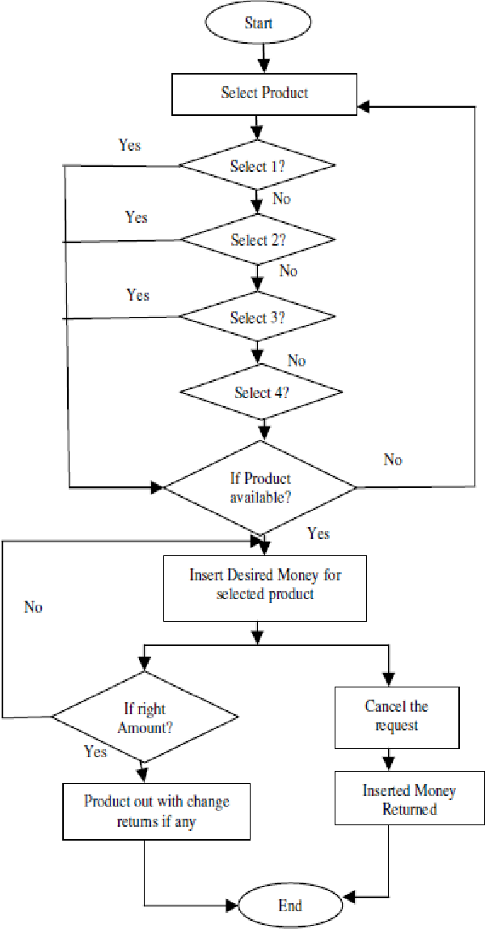

**C++ PROGRAM CODE**

#include<iostream>

#include <string.h>

#include <iomanip>

using namespace std;

struct softdrink

{

char name[20];

float price;

unsigned quantity;

}drink[5];

class vending

{

public:

virtual void access()

{

strcpy(drink[0].name,"Cola"); drink[0].price=0.75; drink[0].quantity=20;

strcpy(drink[1].name,"Root Beer"); drink[1].price=0.75; drink[1].quantity=20;

strcpy(drink[2].name,"Lemon Lime"); drink[2].price=0.75; drink[2].quantity=20;

strcpy(drink[3].name,"Grape Soda"); drink[3].price=0.80; drink[3].quantity=20;

strcpy(drink[4].name,"Cream Soda"); drink[4].price=0.80; drink[4].quantity=20;

cout << fixed;

cout << setprecision(2);

cout<<" WELCOME TO THE VENDING MACHINE! \n";

cout<<"~~~~~~~~~~~~~~~~~~~~~~~~~~~~~~~~~~~~~~~~~~~~~~~~~\n";

cout<<"Please select your drink: \n";

cout<<" 1) "<<drink[0].name<<"\t\t\t"<<drink[0].price<<"\t("<<drink[0].quantity<<") remaining";

cout<<"\n 2) "<<drink[1].name<<"\t\t"<<drink[1].price<<"\t("<<drink[1].quantity<<") remaining";

cout<<"\n 3) "<<drink[2].name<<"\t\t"<<drink[2].price<<"\t("<<drink[2].quantity<<") remaining";

cout<<"\n 4) "<<drink[3].name<<"\t\t"<<drink[3].price<<"\t("<<drink[3].quantity<<") remaining";

cout<<"\n 5) "<<drink[4].name<<"\t\t"<<drink[4].price<<"\t("<<drink[4].quantity<<") remaining";

cout<<"\n 6) Leave the vending machine \n\n";

}

};

class sell: public vending

{

public:

sell(): vending() {}

void run()

{

cout<<"\n Choose a drink: ";

int choice;

cin>>choice;

while(choice!=6)

{

if(choice >=1 && choice <=5)

{

if(drink[choice-1].quantity == 0)

{

cout<<"\n No more " << drink[choice-1].name <<" is available, requires refilling of the machine!";

getchar();

getchar();

continue;

}

}

if(choice == 6)

cout<<"Thank you for using it!";

else if(choice <= 5)

{

float money, price;

cout<<"\n Enter amount inserted: ";

cin>>money;

if(choice>=1 && choice <=3)

{

price = 0.75;

if(money < price)

{

cout<<"\n Enter sufficient amount : ";

getchar();

getchar();

continue;

}

}

else if(choice ==4 || choice ==5)

{

price = 0.80;

if(money < price)

{

cout<<"\n Enter sufficient amount ";

getchar();

getchar();

continue;

}

}

cout<<"\n Thum, thum, thum, splat..Enjoy your beverage!";

cout<<"\n\nChange calculated: "<< money-price;

drink[choice-1].quantity = drink[choice-1].quantity - 1;

cout<<"\nThere are "<< drink[choice-1].quantity <<" drinks left of that type. \n";

cout<<"Thank you for using it! Have a nice day :D \n";

cout<<"~~~~~~~~~~~~~~~~~~~~~~~~~~~~~~~~~~~~~~~~~~~~~~~~~\n";

getchar();

getchar();

}

try

{

if(choice>=6)

throw 6;

}

catch(int choice)

{

cout<<"Out of stock!";

break;

}

}

}

};

int main()

{

vending v;

vending *vptr;

vptr=&v;

vptr->access();

sell s;

sell *sptr;

sptr=&s;

sptr->run();

return 0;

}

**OUTPUT**

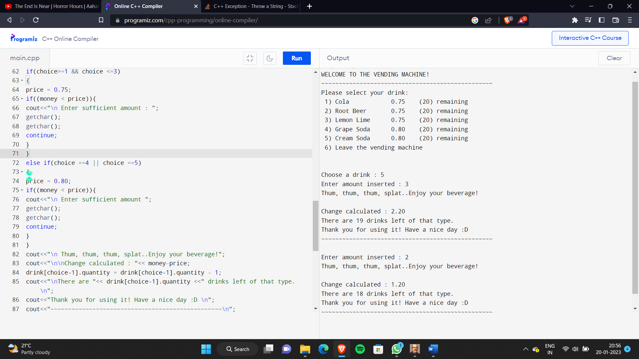

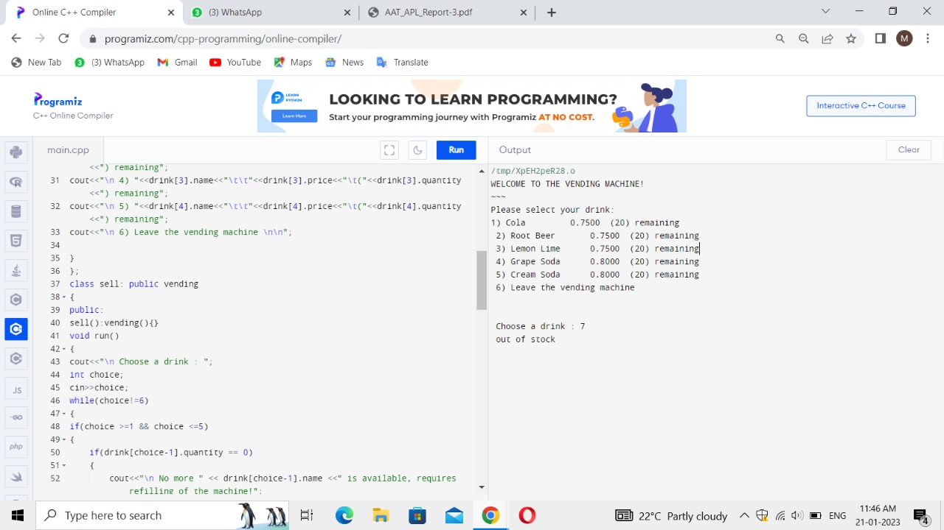

**CONCLUSION**

Thus, our application of mealy finite state machine using C++, that is the implementation of a vending machine, is successfully automated with the mentioned software requirements. The records that are entered in are automatically updated in the database. The above mentioned testing techniques are also performed and our application is finally ready to be deployed to our customers. This has the advantage of maintaining the records properly without any manual stress. Hence, it becomes easier to view the details later. The maintenance of our system completely depends on the customer’s risk.

**REFERENCES**

1. Object Oriented Programming with C++, E. Balaguruswamy, TMH, 6th Edition, 2013.
2. Computer Science with C++, Sumita Arora, 2019.
3. <https://www.cppbuzz.com/programs/c++/c++-program-of-drinking-machine>
4. <https://www.sourcecodesolutions.in/2010/09/petrol-vending-machine-system.html>